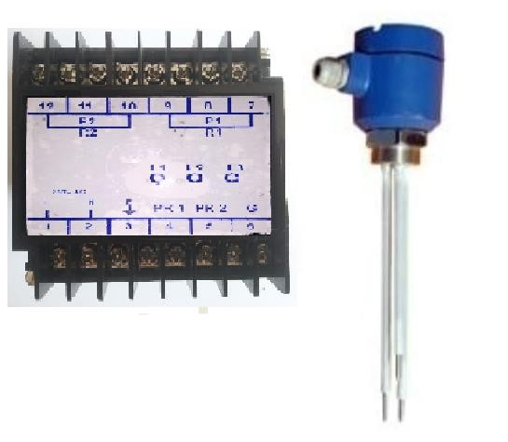

Conductivity level switches are reliable, maintenance-free point level controllers for conductive liquids (≥20 µS/cm), utilizing stainless steel probes to detect liquid presence without any moving parts. Ideal for pump control and alarms in tanks/sumps, they operate at low AC voltage, with options for rigid/flexible probes, Standard temperatures
up to 120°C, and pressure up to 10 bar, and optionally up to 250°C and pressure up to 20 bar.
Conductivity level switches use a low AC voltage between electrodes to detect the presence of a conductive liquid and are used in applications such as water treatment, sumps, and the food industry. We are offering Various models according to customer requirements with different specifications.
Specifications:
Model: CPLS-1700L
Make: Levtron Instruments Pvt Ltd. Pune

Type: Remote Electronics
Supply: 230 V AC/ 24V DC Optional
Output: 5 Amps, SPDT X 2 Nos Potential free Relay.
Sensitivity: Water, Any conductive Liquid.
Conductivity: ≥20 µS/cm and More
Enclosure: ABS, Din rail suitable for Indoor installation
Level 1: Possible in Pump Control logic / Single Point
Level 2: Possible in Pump Control logic / 2nd Point
Ref/Ground: Specify Length
Indications: | On Controller (YELLOW, RED, GREEN)

Process connection: Single Point: individual probe ½” BSP/NPT Onwards,
2 Point Probe: 1-1/2” Screwed / Flanged,
Optionally 2” HDPE/LDPE, Thickness: 10 MM ( Specify)
Probe Length: 25 MM Onwards up to 20 Mtrs. (Specify)
Level 1: ROD/ROPE, Specify Length
Level 2: ROD/ROPE, Specify Length
Ref/Ground: Specify Length
Counterweights: SS 316 x 3 In case of Rope Type
Operating Temp: 0 TO 120° C / Optional 250°C
Operating Pressure: Std: Up to 10 Bar/ Optional 20 Bars
Service: STP, Water applications, Conductive liquids.
Enclosure: Cast Aluminium, Weatherproof
Glands: PG 16 X 1 Nos PVC Glands
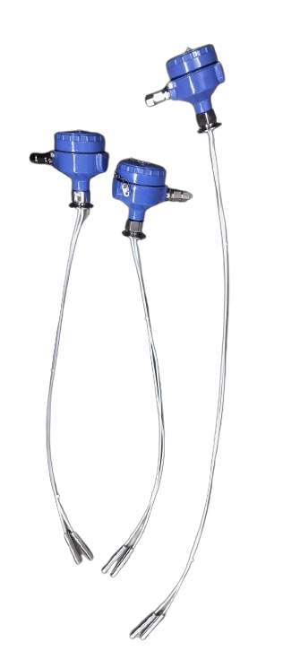
1) Rope Probe:

Levtron Instruments Pvt Ltd.

Office No 02 , 1st Floor ,Plot No 6, Sr. No. 78/1, Pandhari Industrial Estate, Shivane, Pune-411023

GSTIN : 27AAFCL7569M1ZP CIN: U26517PN2024PTC229033
Mob No : 9730042725 /9579430012 Email: Sales@Levtron.in

